**TASK2**

var nestedArray =[

[5,6,7,-2],

[-5,-6,-7],

[8,9,10],

[3,5,2,1,4],

[-3,5,2,1,],

[4,2,6,8],

]

//1. Find Maximum: Write a function to find the maximum number in a nested array of integers.

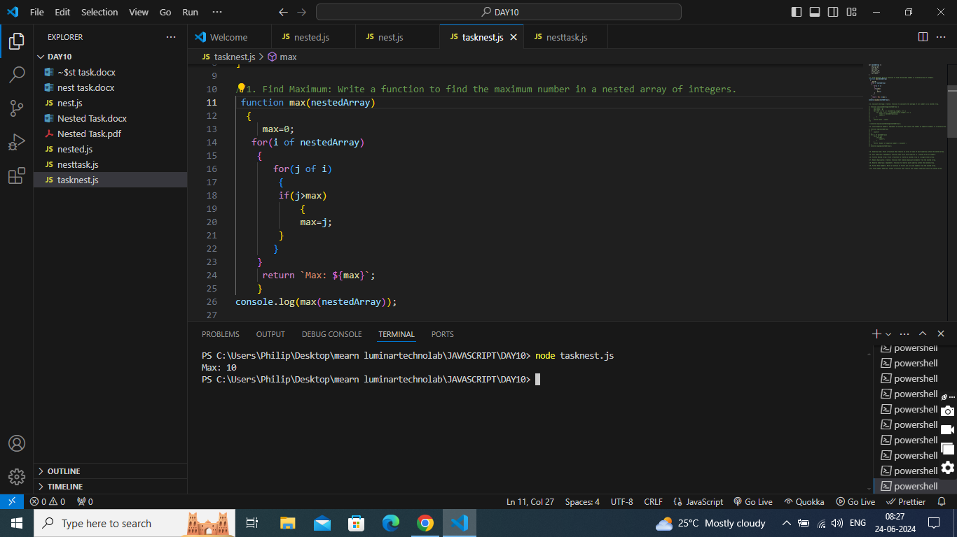

//2. Calculate Average: Create a function to calculate the average of all numbers in a nested array.

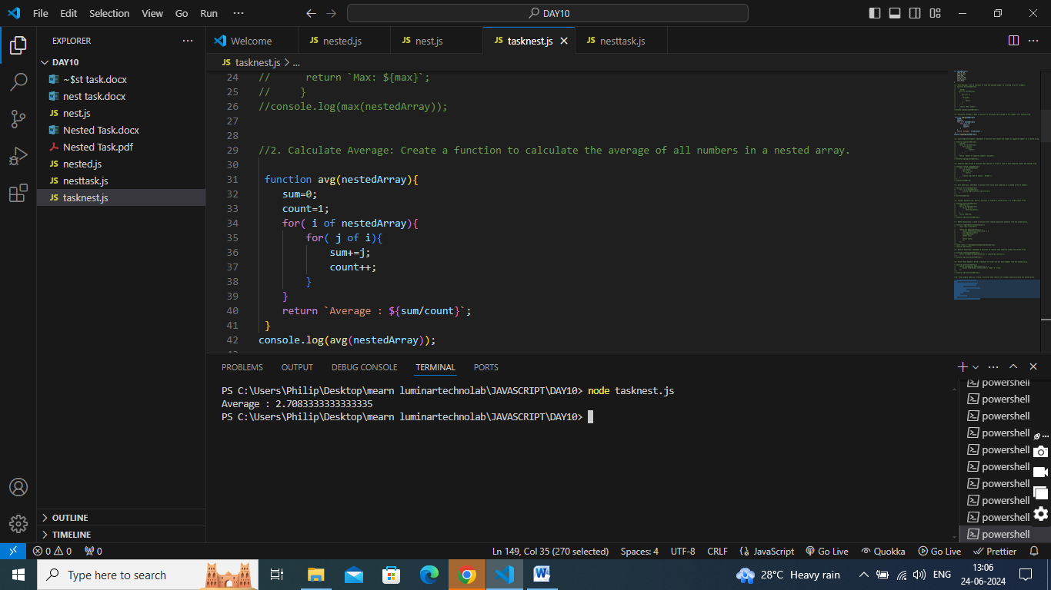

//3. Count Negative Numbers: Implement a function that counts the number of negative numbers in a nested array.

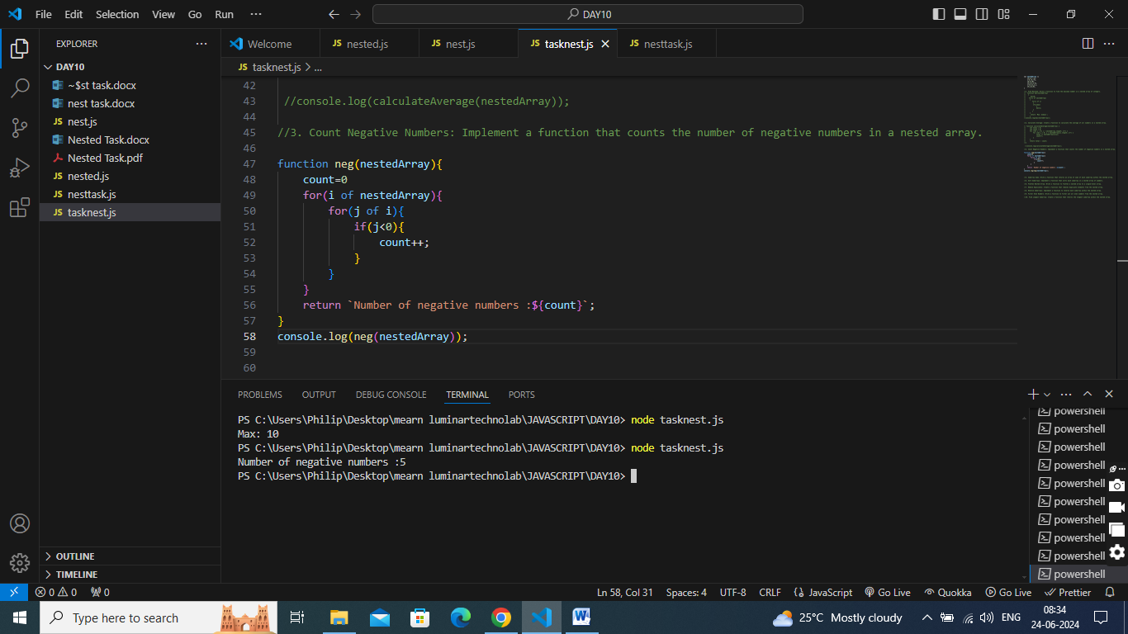

//4. Subarray Sums: Write a function that returns an array of sums of each subarray within the nested array.

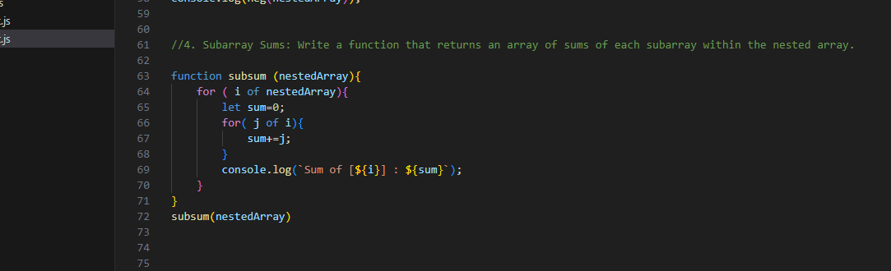

//5. Sort Subarrays: Implement a function that sorts each subarray in a nested array of numbers.

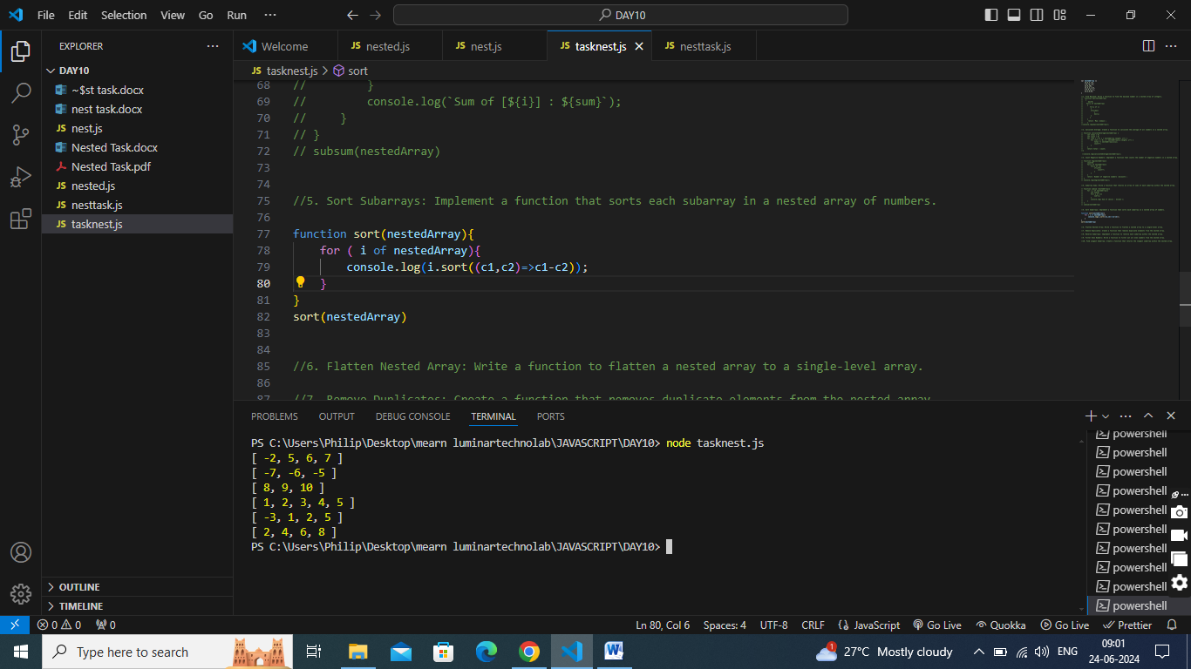

//6. Flatten Nested Array: Write a function to flatten a nested array to a single-level array.

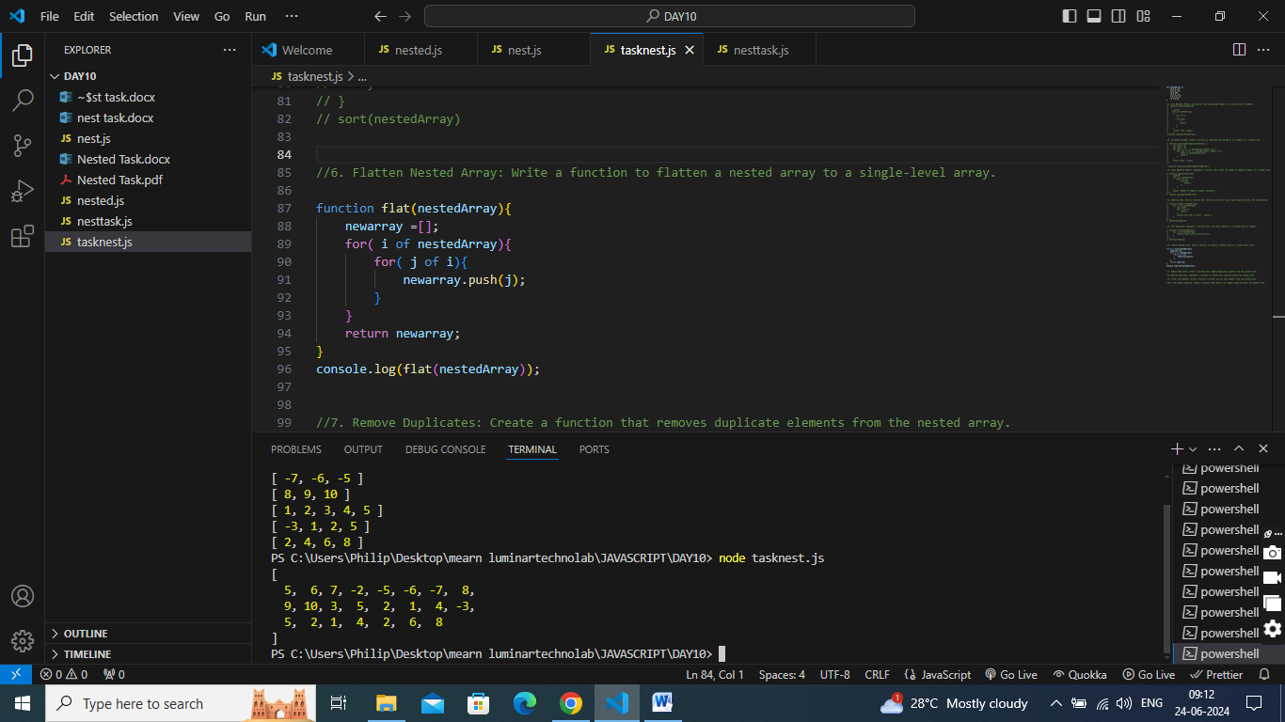

//7. Remove Duplicates: Create a function that removes duplicate elements from the nested array.

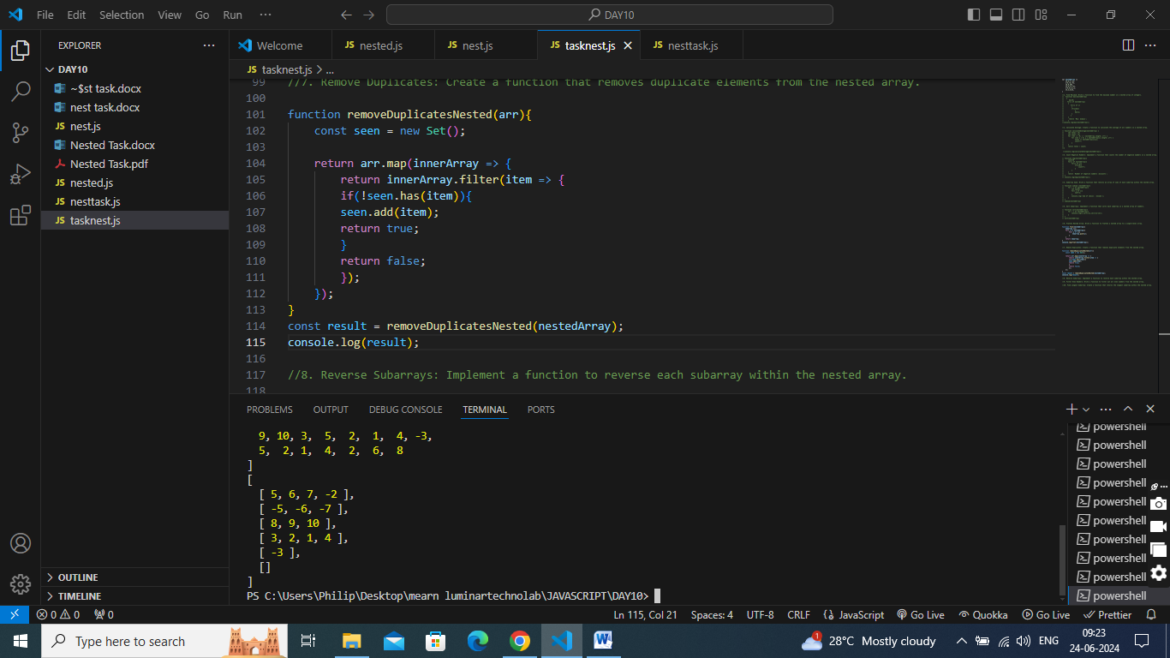

//8. Reverse Subarrays: Implement a function to reverse each subarray within the nested array.

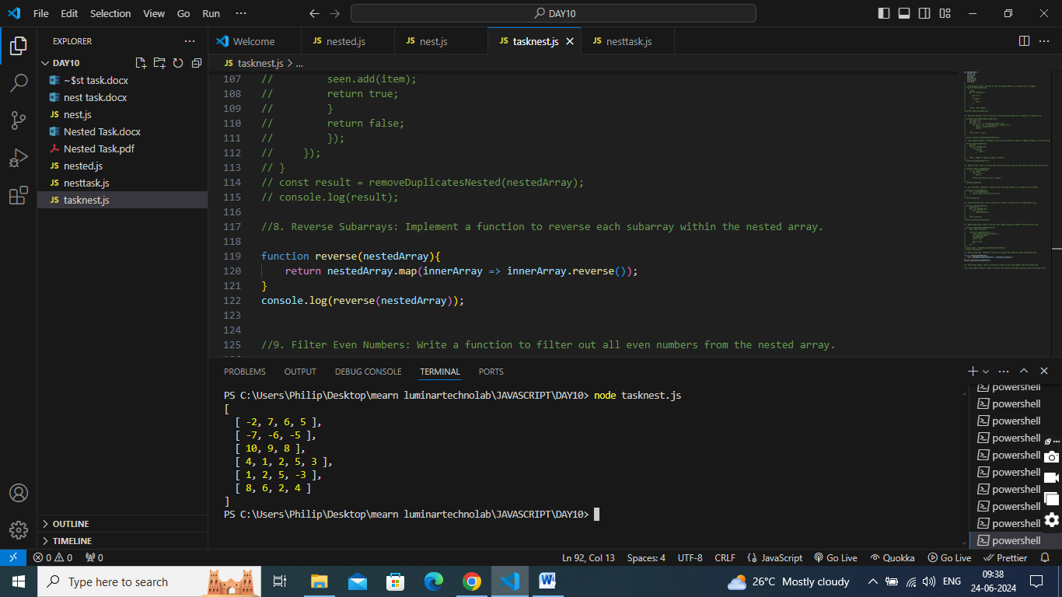

//9. Filter Even Numbers: Write a function to filter out all even numbers from the nested array.

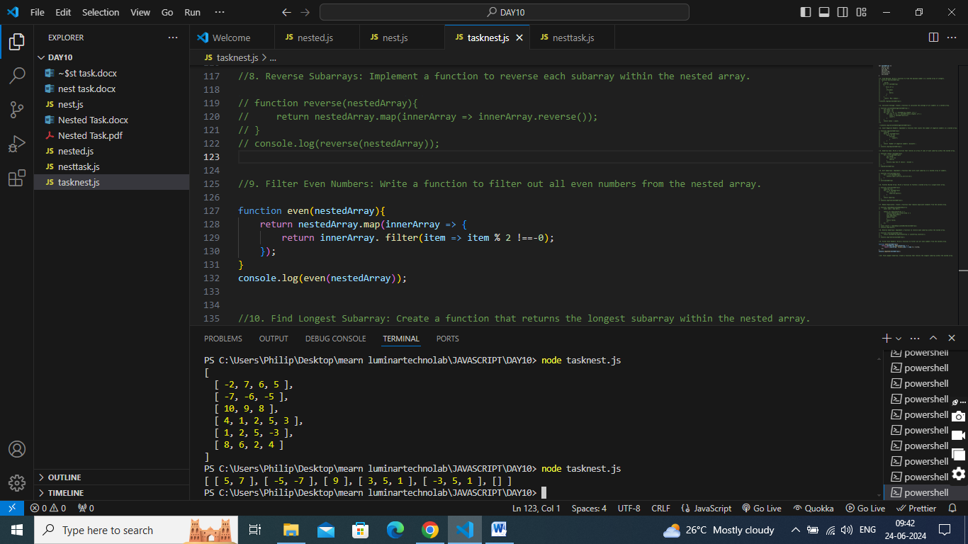

//10. Find Longest Subarray: Create a function that returns the longest subarray within the nested array.

